  

# GMR INSTITUTE OF TECHNOLOGY, RAJAM

(An Autonomous Institution, Accredited by NBA of AICTE, NAAC of UGC & an ISO 9001:2015 Institution)

# STEPCONE 2023

EVENT WISE BUDGET LIST

# STEPCONE 2023

EVENT WISE BUDGET LIST

|  |  |  |  |  |  |  |  |  |  |  |
| --- | --- | --- | --- | --- | --- | --- | --- | --- | --- | --- |
| **Department of ECE**  **Faculty SPOC Nominated: DR. A. SUDHAKAR SIR (ASST PROFESSOR – DEPT OF ECE) Mobile:**  **8106488003** | | | | | | | | | | |
| **S.NO** | **TENTATIVE EVENT** | **REGN. FEE** | **EXPECTED REGISTRATIONS** | **AMOUNT FROM REGISTRATIONS** | **OTHER COSTS** | | **PRIZE MONEY** | | | **BUDGET EXPECTED** |
| **ITEMS** | **PRICE** | **1ST** | **2ND** | **TOTAL** |
| 1 | HOVERCRAFT RACE | 600 | 30 TEAMS | 18,000 | NA | NA | 10,000 | 5,000 | 15,000 | 3000 |
| 2 | AUTOMATED BOTS | 1000 | 50 TEAMS | 50,000 | TRACK | 10,000 | 25,000 | 15,000 | 40,000 | NA |
| 3 | FOX HUNT * | 200 | 50 TEAMS | 10,000 | REQUIRED PARTS & COMPONENT | 5,000 | 2,000 | 1,000 | 3,000 | 2,000 |
| 4 | TINKER CAD | 200 | 30 TEAMS | 6,000 | BASIC REQUIREMENTS | 2,000 | 4,000 | 2,000 | 6,000 | **2,000 REQUIRE** |
| 5 | **TOTAL** |  |  | 84,000 |  | 17,000 | 41,000 | 23,000 | 64,000 | 3000 |
| 6 | **ALUMINI INTERACTION** | NO |  |  |  |  |  |  |  |  |

*-SPOT EVENTS

**Tentative Event: HOVERCRAFT RACE**

**Budget Proposed: Rs.18,000**

**Target Audience:** **All branches**

**Event Coordinators:** S.Harshith (3rd A), N. Pavan Kumar(3rd B),

**Description:** Hovercrafts are remote controlled boat model project. They hover on a cushion of pressurized air. The race is conducted on plane surface. Two boats are released at a time and race held between them winner boat is qualified to next round. The remote control is using with Bluetooth/Wi-fi module.

**IMAGES OF THE EVENT:**

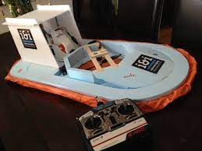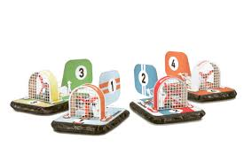

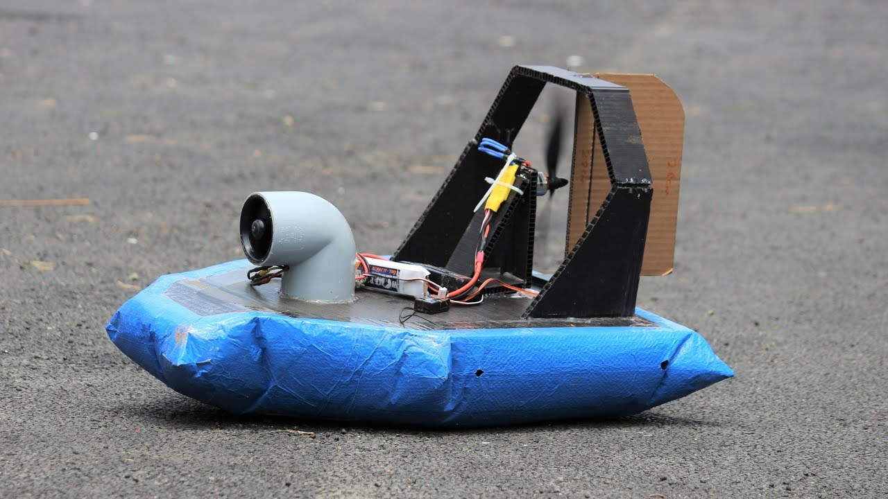

**Tentative Event: AUTOMATED BOTS**

**Budget Proposed:** Rs. **50,000**

**Target Audience:** All branches

**Event co-ordinators:** B. Yaswanth (3rd A), A. Uday Kiran (3rd A)

**Description:** A Robot competition is an event where the abilities and the characteristics of robots may be tested and accessed. Usually, they have to beat other robots in order with the best one. Robots come under wireless communication

**IMAGES OF THE EVENT**



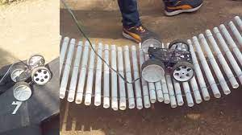 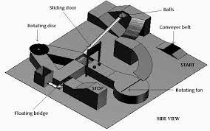  
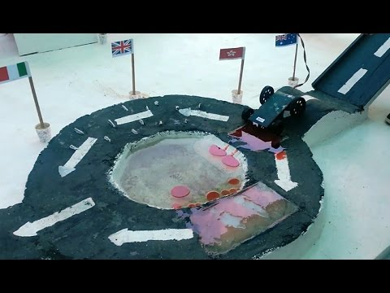

**Tentative Event: FOX HUNT**

**Budget Proposed:** Rs. **8,000/-**

**Target Audience:** All branches

**Event Coordinators:** D. Samanvitha (3rd A), D. Revathi Pati (3rd C), D. Jagan(3rd A)

**Description:** FOX HUNTING is also known as transmitter hunting. The concept of this activity is based on radio direction findings. It has two parts, namely a transmitter and a designated area. For receiver part, it has two antennas with designs. The concept of the event was parting up of transmitters and receivers in less time.

**IMAGES OF THE EVENT:**

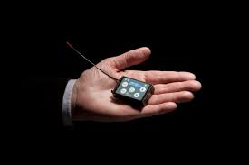 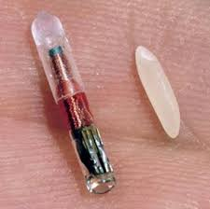

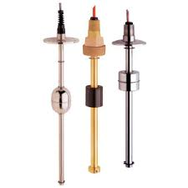

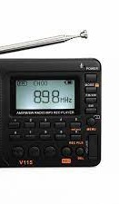

 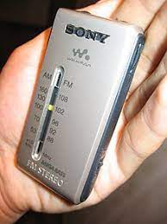

**Tentative Event: TINKER CAD**

**Budget Proposed: Rs.6,000**

**Target Audience:** All branches

**Event Coordinators:** Manoj (3rd B), Sudharshan (3rd B)

**Description:** Tinker cad is an online collection of tools from auto desk that enables complete beginners to create 3D models better than other teams and it is an overnight event. Project to be designed in software.

**IMAGES OF THE EVENT :**

